**Merge commits**: retains all of the commits in your branch and interleaves them with commits on the base branch.

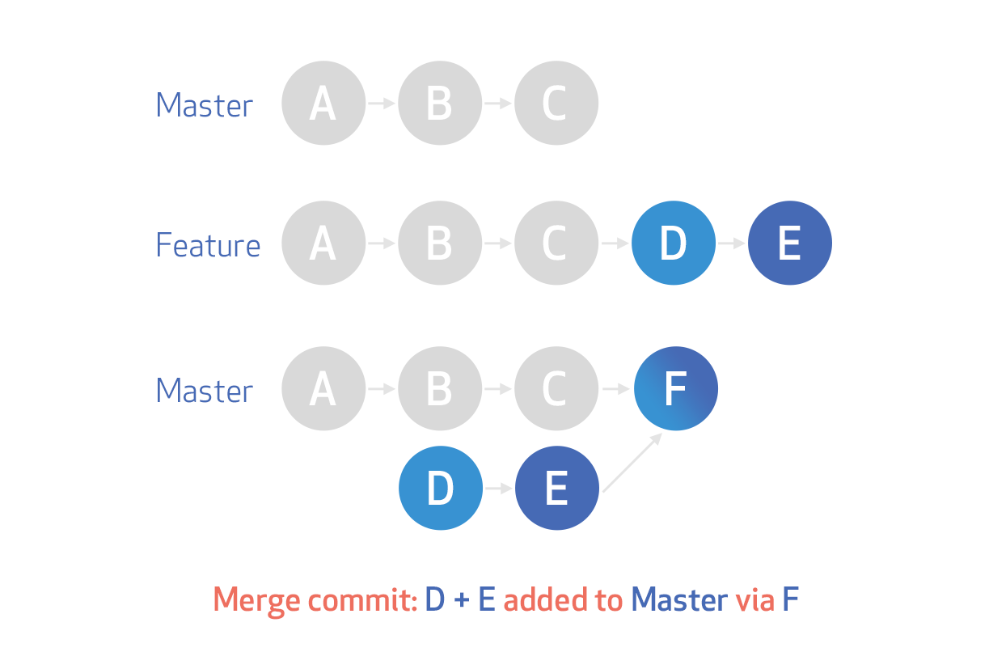

**Merge Squash**: retains the changes but omits the individual commits from history [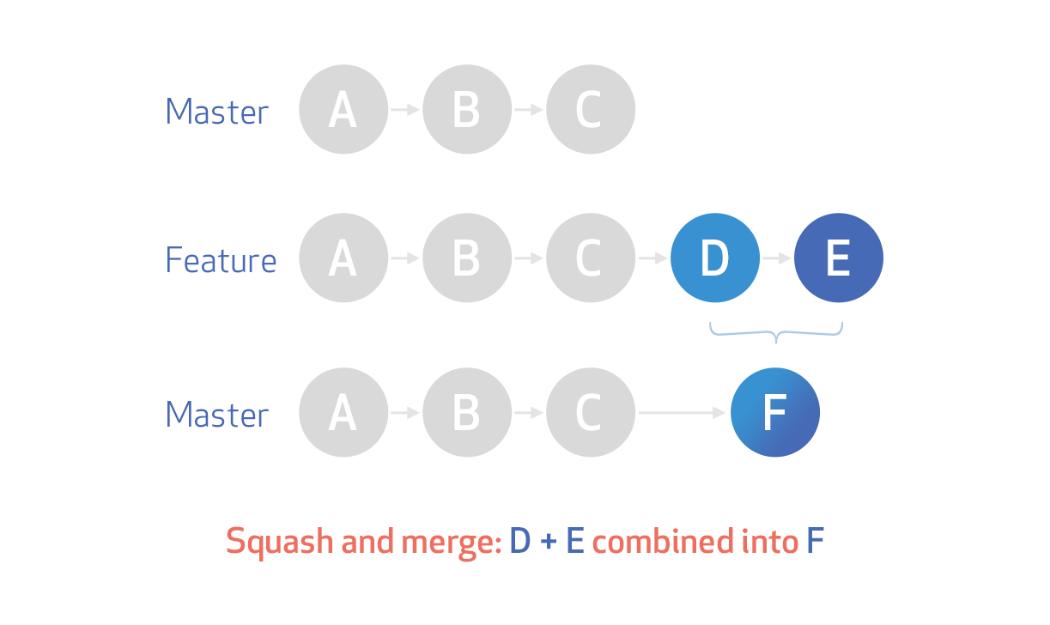](https://i.stack.imgur.com/Lh9LK.png)

**Rebase**: This moves the entire feature branch to begin on the tip of the master branch, effectively incorporating all of the new commits in master

[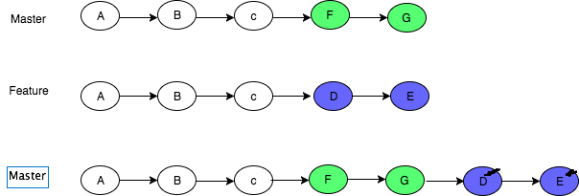](https://i.stack.imgur.com/1tGHe.png)

<https://www.atlassian.com/git/tutorials/merging-vs-rebasing>